**JOINT IMPLEMENTING AGREEMENT**

BETWEEN

**THE CHIEF OF STAFF OF THE FRENCH REPUBLIC**

And

**THE MINISTRY OF DEFENCE OF**

**THE Republic of Slovenia**

***relatED to***

***the ORGANIZATION OF THE EMBARKATION OF A SLOVENIAN DETACHMENT ON A French SHIP ON THE OCCASION OF THE “OLIVES NOIRES” MINE WARFARE EXERCISE***

***from April 8 TO 19, 2024***

The Chief Of Staff Of The French Republic,  
And

The Ministry of Defence of the Republic of Slovenia

Hereinafter referred to respectively as the “French Participant” and the “Slovenian Participant” or jointly “the Participants”;

**Considering**

* the Agreement between the Parties to the North Atlantic Treaty regarding the Status of their Forces, signed in London on 19 June 1951 (hereinafter referred to as NATO SOFA);
* the Agreement on Cooperation in the Field of Defence between the Government of the French Republic and the Government of the Republic of Slovenia, signed in Ljubljana on 18 January 2002;
* Agreement amending the Agreement on Cooperation in the Field of Defence between the Government of the French Republic and the Government of the Republic of Slovenia, signed in Ljubljana on 23 June 2008;
* Agreement between the Government of the Republic of Slovenia and Government of the French Republic on the Exchange and Mutual Protection of Classified Information, signed in Ljubljana on 16 November 2009.

Wishing to develop their cooperation in the field of training their forces in order to increase interoperability between the units of their respective armed forces,

**Agree as follows**

**SECTION 1**

This Joint Implementing Agreement (JIA), aims to specify the practical arrangements for the organization of a Slovenian detachment on a French vessel on the occasion of the “OLIVES NOIRES ” mine warfare exercise beginning on April 8, 2024 and ending on April 19, 2024.

**SECTION 2**

List and function of the members of the Detachment reporting to the Slovenian Participant and benefiting from the training and training resources of the French Participant as part of the Activity:

|  |  |  |
| --- | --- | --- |
| **Grade** | **Name** | **Function** |
| *9 people* | *XXX* | *XXXX* |

**SECTION 3**

The status of respective armed forces on the territory of the French Republic with the purpose of participating in the exercise, including activities directly related to the deployment and redeployment will be determined in accordance with the NATO SOFA.

**SECTION 4**

Pricing for the means and services provided by the French Participant:

|  |  |  |  |
| --- | --- | --- | --- |
| **Human/material resources** | | | **Rate** |
| *Breakfast* | | | *5€/h/day* |
| *Dinner* | | | *17.50€ /h/dinner* |
| *Supper* | | | *17.50€/h/dinner* |
| **Housing** | | | *70.00 €/Night* |
|  |  |

**SECTION 5**

**Invoicing procedure for means and services provided by the French Participant**

* The French Participant's organization supporting the Activity (EMM/GDM –   
  CC ROSENBERG): Draws up a report on means and services made available by the French Participant (based on the appendix I) at the end of the training;
* Makes the Slovenian Participant sign the report;
* Sends the report to the « Economic Analysis » section of the « finance » office of the French naval staff.

The “Economic Analysis” section of the “finance” office of the French Participant naval staff prepares the recovery file in view of the countersigned report then sends it to Slovenian Participant for payment through diplomatic channels.

Payment of the invoice is made by transfer to the bank account whose details appear below. The transfer is marked “Cooperation MN-Slovenian Marine Component”.

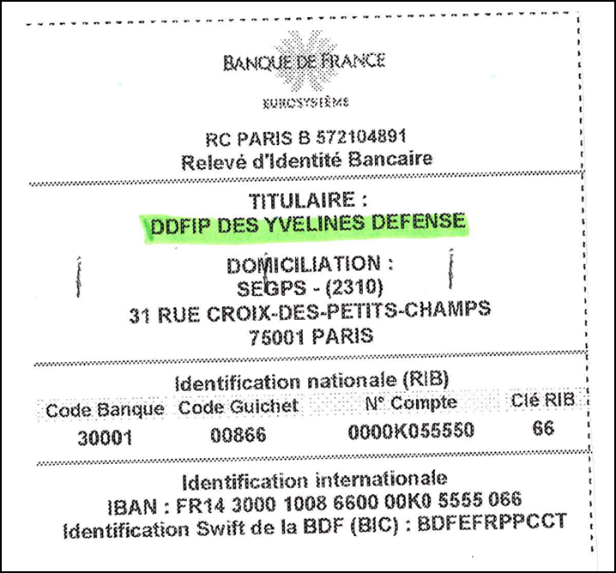

5.2. Touchpoints

1. The Slovenian Participant

LTCDR Miroslav Jug

Tel: XXXX

Functional email address: miroslav.Jug@mors.si

1. The French Participant

**Department in charge of preparing the end of training report**

CC (OF3) ROSENBERG Derrick

[Derrick.rosenberg@intradef.gouv.fr](mailto:Derrick.rosenberg@intradef.gouv.fr)

+33 2 98 22 93 77

**Service in charge of establishing the recovery file**

“Economic analysis” section

Finance office

Naval Staff

60 Boulevard Martial Valin

75,015 Paris - FRANCE

Functional email address: emm-fin-ae.cds.fct@intradef.gouv.fr

**SECTION 6**

**Planning contact points**

1. The Slovenian Participant

LTCDR Miroslav Jug

Tel: XXXX

Functional email address: miroslav.Jug@mors.si

1. The French Participant

CC (OF3) ROSENBERG Derrick

[Derrick.rosenberg@intradef.gouv.fr](mailto:Derrick.rosenberg@intradef.gouv.fr)

+33 2 98 22 93 77

**Execution touchpoints**

* 1. The Slovenian Participant

LTCDR Miroslav Jug

Tel: XXXX

Functional email address: miroslav.Jug@mors.si

* 1. The French Participant

CC (OF3) ROSENBERG Derrick

[Derrick.rosenberg@intradef.gouv.fr](mailto:Derrick.rosenberg@intradef.gouv.fr)

+33 2 98 22 93 77

**SECTION 7**

It is the responsibility of the Slovenian Participant to ensure that the members of the Slovenian detachment are medically and dentally fit prior to their arrival in the territory of the Host Nation.

All members of the Slovenian detachment must have appropriate health insurance prior to their arrival in the territory of the Host Nation, for reasons of payment of possible medical treatment costs.

The costs incurred from public healthcare providers for members of the Slovenian detachment which are not covered by the health insurance will be paid by the Slovenian Participant under the prices applicable in the Host Nation at the time.

Medical and dental care will be provided to the members of the Slovenian detachment under the same conditions as for the Host Nation Armed Forces' members in accordance with Article IX of NATO SOFA.

Emergency medical treatment and consultations provided by the military medical services of the Host Nation, and evacuation by military transport to the nearest medical facility, where available, will be free of charge.

All members of the Slovenian detachment must bring sufficient prescription medication for personal use for the duration of the activities in connection with this JIA.

**SECTION 8**

The death of a member of the Slovenian detachment in the territory of the French Participant must be reported immediately to the competent Host Nation authority.

Death will be certified by an authorized Host Nation doctor.

If the competent Host Nation authority requests that an autopsy is carried out on the deceased, this is done by an authorized HN doctor. A doctor appointed by the Slovenian authorities may be present at the autopsy, which will take place at a time and location stipulated by an appropriate Host Nation authority.

In the event of the death of a member of the Slovenian detachment in the territory of the Host Nation, the Slovenian Participant will cover all costs related to the transport of the remains and personal belongings of the deceased to the territory of the Republic of Slovenia.

The post-mortem examination, autopsy and transport of the remains will be carried out in accordance with the Host Nation regulations.

**SECTION 9**

Any claim arising from this JIA will be managed in accordance with the provisions contained in the NATO SOFA and the aforementioned Intergovernmental Agreement on the cooperation in the field of Defence.

**SECTION 10**

Any disagreement arising from the interpretation or implementation of this JIA will be resolved solely by mutual consultations between the Participants and will not be referred to any national or international court or tribunal or third party for settlement.

**SECTION 11**

This JIA comes into effect on the date of the last signature.

This JIA may be amended at any time by the mutual written consent of the Participants.

Either Participant may discontinue this JIA at any time with a written notice to the other Participant. In such event, this TA will be discontinued on the 30th day following the receipt of such written notice.

This JIA does not create any rights or obligations under international law.

This JIA is signed in two original copies, in the French, Slovenian and English languages, all versions being equally authoritative.

|  |  |
| --- | --- |
| Signed at …………………. on …………….. | Signed at …………………. on …………….. |
| **For the Chief of Staff of the French Republic**  For the Chief of Staff of the French Navy, and by delegation  Rear Admiral Jean ‑Marc DURANDAU  *Coordinating Authority*  *for international relations* | **For the Ministry of Defence of the Republic of Slovenia**  CAPT-N Bogomir Tomažič, CO Naval Division of Slovenian Armed Forces |
| **Signature:** | **Signature:** |

**Appendix i: TYPICAL report OF MEANS MADE AVAILABLE**

|  |  |  |  |  |  |  |  |
| --- | --- | --- | --- | --- | --- | --- | --- |
| **Human/material resourcess** | | | **Rate** | **Quantities** | | **Usage time (in hours)** | |
|  | | |  |  | |  | |
|  | | |  |  | |  | |
|  | | |  |  | |  | |
|  | | |  |  | |  | |
|  |  |  | | |  | |