TECHNICAL ARRANGEMENT (TA) No A.PRG.CAP672.A concluded under
PROGRAMME ARRANGEMENT (PA) No A.PRG.CAP672

BETWEEN

THE MINISTER OF DEFENCE OF THE KINGDOM OF BELGIUM
THE MINISTRY OF DEFENCE OF THE REPUBLIC OF BULGARIA
THE MINISTRY OF DEFENCE OF THE REPUBLIC OF CROATIA
THE MINISTRY OF DEFENCE OF THE REPUBLIC OF CYPRUS
THE MINISTRY OF DEFENCE OF THE CZECH REPUBLIC
THE MINISTRY OF DEFENCE OF THE REPUBLIC OF ESTONIA
THE MINISTRY OF DEFENCE OF THE REPUBLIC OF FINLAND
THE MINISTER OF DEFENCE OF THE FRENCH REPUBLIC
THE FEDERAL MINISTRY OF DEFENCE OF THE FEDERAL REPUBLIC OF GERMANY
THE MINISTRY OF NATIONAL DEFENCE OF THE HELLENIC REPUBLIC
THE MINISTRY OF DEFENCE OF THE ITALIAN REPUBLIC
THE MINISTRY OF DEFENCE OF THE REPUBLIC OF LATVIA
THE MINISTRY OF NATIONAL DEFENCE OF THE REPUBLIC OF LITHUANIA
THE MINISTER OF DEFENCE OF THE GRAND DUCHY OF LUXEMBOURG
THE MINISTER OF DEFENCE OF THE KINGDOM OF THE NETHERLANDS
THE MINISTRY OF DEFENCE OF THE KINGDOM OF NORWAY
THE MINISTER OF NATIONAL DEFENCE OF THE REPUBLIC OF POLAND
THE MINISTRY OF NATIONAL DEFENCE OF THE PORTUGUESE REPUBLIC
THE MINISTRY OF NATIONAL DEFENCE OF ROMANIA
THE MINISTRY OF DEFENCE OF THE SLOVAK REPUBLIC
THE MINISTRY OF DEFENCE OF THE REPUBLIC OF SLOVENIA
THE MINISTRY OF DEFENCE OF THE KINGDOM OF SPAIN
THE GOVERNMENT OF THE KINGDOM OF SWEDEN
AND
THE EUROPEAN DEFENCE AGENCY

On

CROSS BORDER MOVEMENT PERMISSION PROCEDURES FOR AIR MOVEMENT IN EUROPE

Hereafter to be referred to as “CBMP AIR TA”

PROGRAMME ARRANGEMENT (PA) No A.PRG.CAP672

TABLE OF CONTENT INTRODUCTION 6
PART 1: GENERAL 9
CHAPTER I - AIM AND OBJECTIVES 9
PART 2: AIR MOVEMENT SPECIFICS 10
CHAPTER II - SCOPE AND PROVISIONS 10
SECTION 1. AIR MOVEMENTS COVERED 10
SECTION 2. AIR MOVEMENT PROVISIONS 10
CHAPTER III - ANNUAL DIPLOMATIC CLEARANCE PRINCIPLES 11
SECTION 1. ADMINISTRATIVE PROCESS 11
SECTION 2. SPECIFIC MOVEMENTS FORESEEN FOR AN ANNUAL DIPLOMATIC CLEARANCE 11
CHAPTER IV - OTHER ASPECTS RELATED TO MOVEMENT 12
SECTION 1. PRIORITIZATION OF MILITARY MOVEMENT IN PEACE TIME 12
SECTION 2. MILITARY MOVEMENT DURING NATIONAL HOLIDAYS AND/OR CELEBRATIONS 12
PART 3: TA ENTERING INTO EFFECT 13
CHAPTER V - FINAL PROVISIONS 13
SECTION 1. LEGAL ASPECTS 13
SECTION 2. DURATION 13
SECTION 3. AMENDMENT 13
SECTION 4. WITHDRAWAL AND TERMINATION 13
SECTION 5. ADMISSION OF NEW MEMBERS 14
SECTION 6. SIGNATURE AND DATE OF COMING INTO EFFECT 14
ANNEX A MOVEMENT REQUEST/NOTIFICATION/APPROVAL TEMPLATE 15
ANNEX B DECLARATION OF INTENT 19

DEFINITIONS AND ABBREVIATIONS

AIP | Aeronautical Information Publication  A publication issued by or with the authority of a state and containing aeronautical information of a lasting character essential to air navigation.  Some states issue a specific military AIP complementary to the civil AIP, while others combine all procedures in one AIP.
AMovP-6 | Allied Movement Publication 6 is the Allied Multi-Modal  Transportation Of Dangerous Goods Directive. AMovP-6 sets out the policy, guidance and criteria for the safe movement of ammunition and explosives by all modes of transport. This NATO Directive is made public to EU Member States.
CBMP PA | Cross Border Movement Permission Programme Arrangement  (Programme Arrangement No A.PRG.CAP672 on the optimising cross border movement permission procedures in Europe).
cM(s) | Contributing Member(s) to this Technical Arrangement
DCN | Diplomatic Clearance Number
Diplomatic clearance | Authorization to enter and transit in a member state’s airspace/territory, obtained at political/diplomatic level. Might be obtained at or delegated to the military authority.
EATC | European Air Transport Command
EDA | European Defence Agency
EGOM | EATC Ground Operations Manual
Fixed wing platforms | Heavier-than-air aircraft with wings which remain in a fixed position under given conditions of flight; may include variable geometry aircraft.
IATA | International Air Transport Association
ICAO | International Civil Aviation Organization
ISTAR | Intelligence, Surveillance, Target Acquisition, and Reconnaissance
Military aircraft | “Military aircraft” signifies a military-registered / -operated aircraft used for non-commercial purposes.
Military Movement | The change of location of forces, equipment, personnel and stocks as part of a military activity. Military movement requires the supporting capabilities of mobility, transportation, infrastructure, movement control and support functions.
Movement Notification | The act of informing concerned cM(s) about upcoming military movement on their territory/airspace.
NPOC(s) | National Point(s) of Contact designated by the respective cM(s).
PA-cM(s) | Contributing Member(s) to the CBMP Programme (those that signed or accede to the CBMP PA).
Participants | All cM(s) and EDA
Rotary wing platforms | Heavier-than-air aircraft supported in flight chiefly by the reactions of the air on one or more rotors on substantially vertical axes, including tilt-rotor vehicles.
SRD | Standard Related Document, as referred to in the AMovP-6

INTRODUCTION
The Participants to the present TA:
- Considering Council Decision (CFSP) 2015/1835 of 12 October 2015 defining the statute, seat and operational rules of the European Defence Agency and repealing Joint Action
2004/551/CFSP of 12 July 2004 on the establishment of the European Defence Agency;
- Considering the Action Plan on Military Mobility JOIN (2018) 5 final adopted by the High representative and the Commission on 28.03.2018, approved by the Council on 25 June 2018;
- Considering Council Conclusions n°10246/18 regarding military mobility dated 25 June 2018;
- Considering the Joint Report to the European Parliament and the Council on the Implementation of the Action Plan on Military Mobility JOIN (2020) 16 final 19 Oct 2020, or any subsequent document;
- Considering the Agreement between the Member States of the European Union concerning the status of military and civilian staff seconded to the institutions of the European Union, of the headquarters and forces which may be made available to the European Union in the context of the preparation and execution of the tasks referred to in Article 17(2) of the Treaty on European Union, including exercises, and of the military and civilian staff of the member States put at the disposal of the European Union to act in this context (EU SOFA), done on 17 November 2003 and the Agreement between the Parties to the North Atlantic Treaty Regarding the Status of their Forces signed in London on 19 June 1951 (NATO SOFA) and the Agreement Among States Parties to the North Atlantic Treaty and the Other States Participating in the Partnership for Peace regarding the Status of their Forces, signed in Brussels on 19 June 1995, (PfP SOFA);
- Considering the approval by the Council of the Military Requirements for Military Mobility within and beyond the EU (ST 11373/19), approved by the Council on 19 July 2019), as being revised on a regular basis;
- Considering the EDA Steering Board Decision SBD 2018/13 dated 29 May 2018 approving the
“Optimising Cross Border Movement Permission procedures in Europe” as an Ad Hoc Category A Programme;

- Recognising that activities and operations are conducted in a multinational environment that mutual support and cooperation can significantly enhance operational readiness and ability to deploy the forces, in the framework of Military Mobility;
- Recognising that Military Mobility is an area for EU-NATO cooperation in the frame of the implementation of the Warsaw Joint Declaration and the Brussels Joint Declaration;
- Recognising that the deployments, sustainment and redeployments of Defence/Armed Forces remain a national responsibility;
- Recognising the fundamental principle of national sovereignty, meaning that the States of cM(s) retain control of entry into/overflight of their territory at all times;
- Recognising that this Technical Arrangement or any other measure adopted in its implementation, shall be understood without prejudice to the legal position of the Kingdom of Spain regarding its sovereignty and jurisdiction in relation to the territory of Gibraltar. The use of Spanish territory for movements of troops having its origin or destination in the territory of Gibraltar shall be prohibited. The use of the airspace of sovereignty of Spain will be prohibited for arrivals or departures of aircraft included in this agreement to / or the Gibraltar aerodrome, except in cases of humanitarian aid and MEDEVAC / CASEVAC duly authorized by Spain;
- Pursuant to the EDA Category A Programme Arrangement entitled Optimising Cross Border Movement Permission procedures in Europe (CBMP PA) No A.PRG.CAP672, which came into effect on 14 May 2019, and is aiming to improve CBMP procedures in Europe to facilitate military movement through EU countries by harmonising procedures to shorten lead times;
- Acknowledging the need to react, by moving their forces over the borders of other cM(s), as well as recognising the value of exercising on cross border movement processes and procedures;
- Acknowledging the convention on international civil aviation done at Chicago on the 7th December 1944;
- Acknowledging the Technical Instructions For The Safe Transport of Dangerous Goods by Air (ICAO-T.I.) and their related supplements;
- Acknowledging the AMovP-6 (ALLIED MULTI-MODAL TRANSPORTATION OF DANGEROUS GOODS DIRECTIVE);
- Acknowledging the International Air Transport Association Dangerous Goods Regulations (IATA-DGR);
- Acknowledging the principles of EATC Ground Operations Manual (EGOM).

Have reached the following understanding concerning this TA entitled:

"CROSS BORDER MOVEMENT PERMISSION PROCEDURES FOR AIR
MOVEMENT IN EUROPE" (CBMP AIR TA)

PART 1: GENERAL

CHAPTER I - AIM AND OBJECTIVES
- The aim of this TA is to improve air CBMP procedures in order to facilitate air military movements through the territories/airspaces of the states of the cMs. This is to be achieved by harmonizing and simplifying the movement approval process for military aircraft, harmonizing the procedures, shortening lead-times according to the agreed objectives, and developing optimised solutions without additional bureaucratic burden while avoiding unnecessary duplication concerning existing procedures and processes within the competence of the participants. The cMs might achieve the aim of the TA by further addressing requests for harmonization and simplification of laws, regulations and procedures, to the competent European and national authorities.
- In this TA the cMs describe a desired end-state, providing European and/or national competent authorities with recommendations on specific and appropriate measures/actions, which should be implemented at the national level in order to achieve the aim of the TA.
- Each cM is encouraged to strive to achieve the objectives of this TA. In this effort, the sovereignty, national decision-making and constitutional requirements of individual cM(s) as well as the specific character of their security and defence policies remain fundamental and will be fully respected.

PART 2: AIR MOVEMENT SPECIFICS

CHAPTER II - SCOPE AND PROVISIONS

Section 1. Air movements covered
- This TA covers all fixed- and rotary wing platforms.
- A diplomatic clearance granted in context with this TA (both ad hoc and annual) may also apply to civil-registered assets when used exclusively for military services.
- Specific air movements that are, by means of this TA, foreseen for cMs to grant each other an annual diplomatic clearance are described in Part 2, Chapter III, Section 2 below.
- In case that for a specific air movement an annual diplomatic clearance is not foreseen by this TA, such movement will require a request for an ad hoc diplomatic clearance. The cMs will, in principle, reply to each other’s ad hoc diplomatic clearance requests within five working days.
- Weapons of mass-destruction (e.g. chemical/biological/nuclear) and depleted uranium (DU) ammunition are excluded from the movements with regard to the applicability of this TA.
- If the laws and regulations in force in the states of the cMs and/or bilateral or multilateral agreements or arrangements between cMs provide for less restrictive procedures than those laid down in this TA, these laws and regulations will prevail.
- Any cM can impose geographic or other specific limitations on military movements into/through its territory/airspace.

Section 2. Air movement provisions
- The diplomatic clearance (both ad hoc and annual) does neither relieve the cMs from obtaining relevant operational approvals nor does it include an approval to use a specific airspace or aerodrome.
- Any type of ISTAR and/or electronic warfare equipment, as well as defensive aids sub-systems, have to be rendered inoperative, unless the operation of such equipment is an essential element of a specific mission, the intention about the equipment usage (including information where and when) is indicated in the movement request/notification, and specifically authorised according to the regulation by the states of the cMs affected (for example AIP).
- The sending cM will use the territory/airspace and conduct, for example, air-to-air refuelling, training range activity, and aerial combat training, as regulated by the state affected.
- The cMs make use of the standardised movement request/notification/approval template (Annex A).
- The DCN will be mentioned in item 18 of the ICAO Flight Plan.

CHAPTER III - ANNUAL DIPLOMATIC CLEARANCE PRINCIPLES

Section 1. Administrative process
- An annual diplomatic clearance in the context of this TA signifies a diplomatic clearance issued between cMs, on a renewable basis, for a calendar year, starting January 1st of each year. In principle, two months before the end of the calendar year, cMs will send a request to all other cMs to grant or renew the annual diplomatic clearance for the next year.
- Air movements under such annual diplomatic clearance require a notification to be sent to the NPOC at the latest two working days before the date of the movement. A cM may specify exemptions to other cMs towards this notification requirement.

Section 2. Specific movements foreseen for an annual diplomatic clearance
- Movements of unarmed, manned platforms (for example transport, air-to-air refuelling, training range activity, and aerial combat training), under the following provisions:
  - captive and training ammunition may be installed on the platform, if no propulsion and/or warhead is installed (e.g. captive air-to-air training missile);
  - chaff/flare-cartridges may be installed on the platform (usage is subject to regulations of affected state).
- Movement of dangerous goods cargo, under the provision that the transportation, composition, preparation, and handling is according to the guidelines and instructions laid down in the ICAO T.I. and the related supplements / IATA-DGR, or AMovP-6 SRD 6 (Transport by Air), as applicable, and the principles described in the EGOM are observed.

CHAPTER IV - OTHER ASPECTS RELATED TO MOVEMENT

Section 1. Prioritization of military movement in peace time
Upon request from a sending cM, cMs will take available measures to prioritize military movement.

Section 2. Military movement during national holidays and/or celebrations
The cMs will take available measures to facilitate and enable military movement also during holidays, national celebrations and weekends.

PART 3: TA ENTERING INTO EFFECT

CHAPTER V - FINAL PROVISIONS

Section 1. Legal Aspects
- Any difference in the interpretation or application of this TA will be resolved solely by consultation between the Participants.
- All claims arising within the context of the performance of the TA will be dealt with in accordance with international and national laws and regulations of the cMs.
- This TA does not constitute a treaty as defined by the 1969 Vienna Convention on the Law of Treaties. In case of any conflict between this TA and international or national laws and regulations of the cMs, the latter will prevail. The cMs to the TA will notify each other in the event of any such conflict.

Section 2. Duration
This TA will remain effective unless all cMs consent in writing to its termination on the proposal of any of the Participants.

Section 3. Amendment
- Upon cM(s) proposal, this TA may be amended at any time in writing by unanimous decision of all the cMs for which the TA has become effective, taking into account that no amendment can be made to this TA or its annexes in the first 6 months following the coming into effect of this TA.
- Upon a proposal by cM(s), annexes to this TA may be modified by consensus of all the cMs for which the TA has become effective through a 60 calendar days silence procedure, organised by EDA. After this period has ended and if no objections have been raised, the modifications will become effective. EDA will provide a communication on the outcome to the cMs. Modifications to the Annexes do not constitute an amendment to the TA.

Section 4. Withdrawal and Termination
- Any cMs can withdraw from this TA at any time at their own discretion via a written notice to EDA, two months prior to the desired withdrawal date. EDA will notify the remaining cMs.
- In case of termination of this TA or the withdrawal from the TA by any cMs, the commitments arising from this TA (e.g. provided annual permission) during their period of validity remain in effect.
- A cM that withdraws from the CBMP PA will simultaneously withdraw from this TA. Termination of the CBMP PA also means termination of this TA. In case of termination of the CBMP PA or the withdrawal from the CBMP PA by any cM, the commitments arising from this TA during their period of validity remain in effect.

Section 5. Admission of new Members
- Any PA-cM will become a cM by means of a Declaration of Intent both in the English and French language (enclosed at Annex B to this TA) at the date of signature of this declaration. The Declaration of Intent will be sent to EDA, which will inform all cMs.
- EDA will accordingly update the list of cMs on the front page of this TA. This update does not constitute an amendment to the TA.

Section 6. Signature and date of Coming into Effect
- This TA will be signed both in the English and French languages, each version being equally valid. The original will be held by the EDA, with one certified true copy being sent to each cM, upon request.
- This TA will become effective at the date of signature of a minimum of 10 cMs and EDA. For other cMs this TA will become effective on their respective date of their signature.

ANNEX A MOVEMENT REQUEST/NOTIFICATION/APPROVAL TEMPLATE

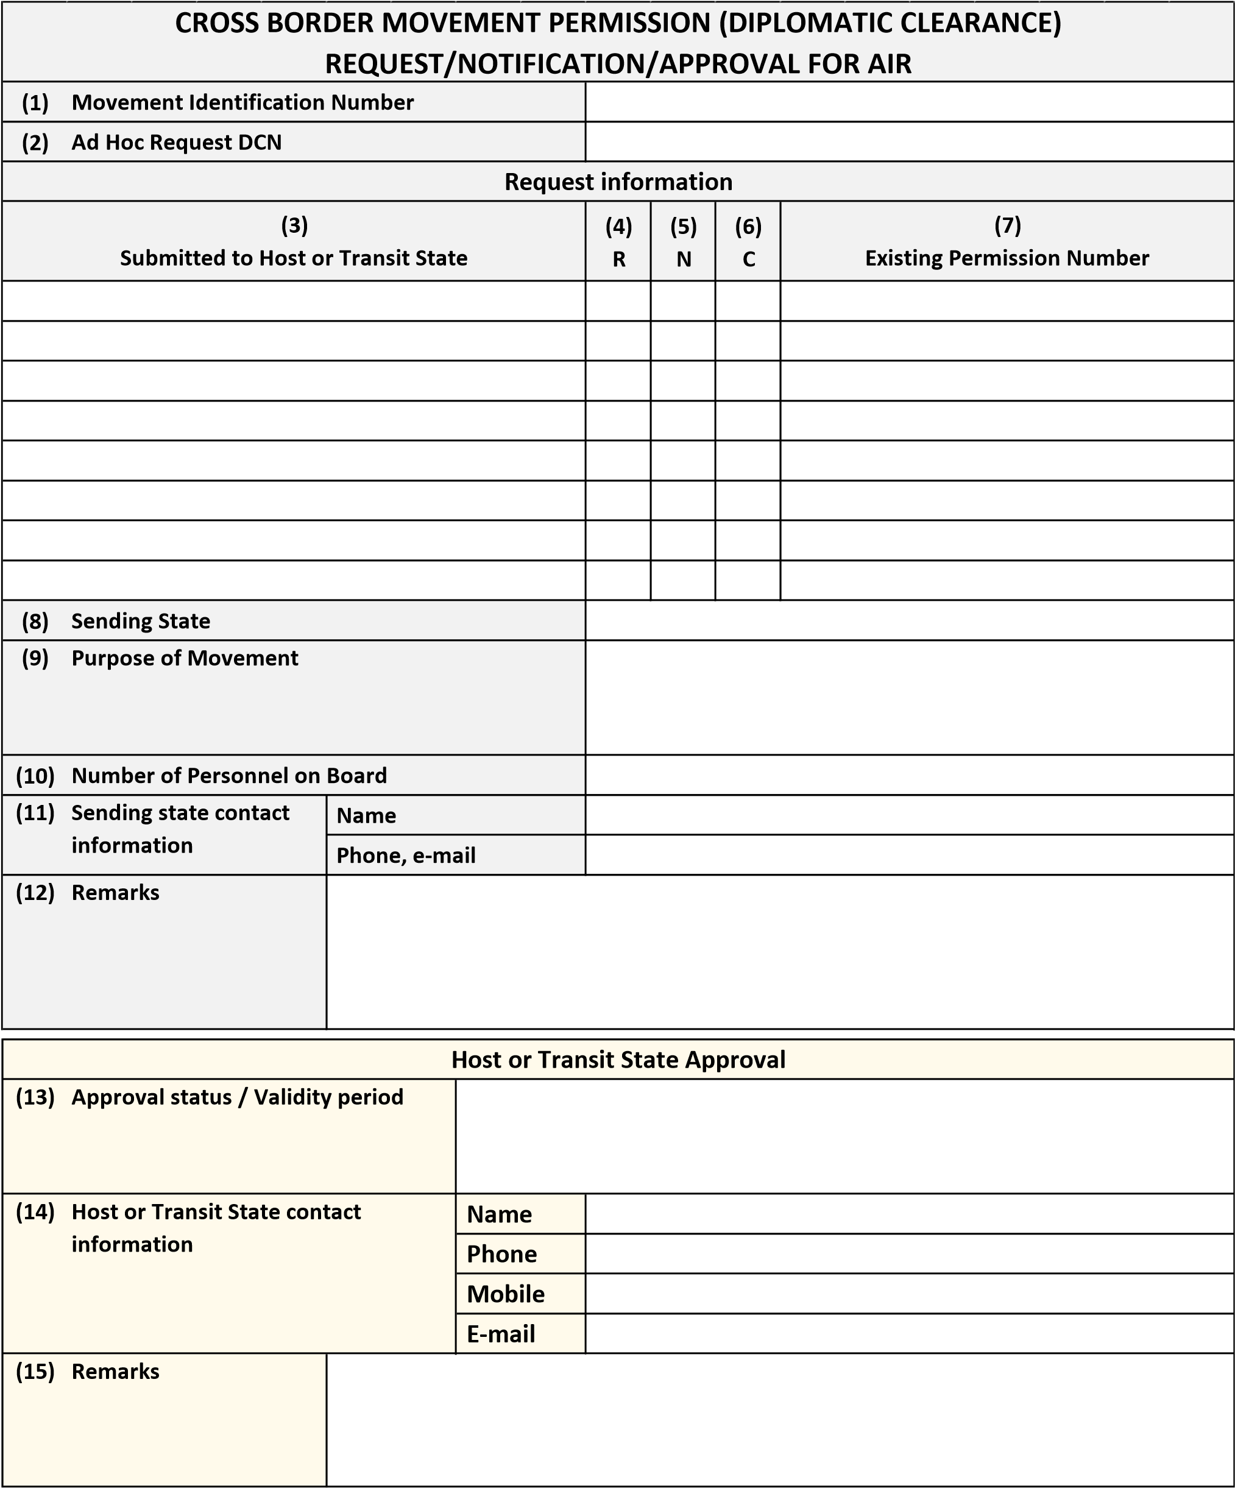

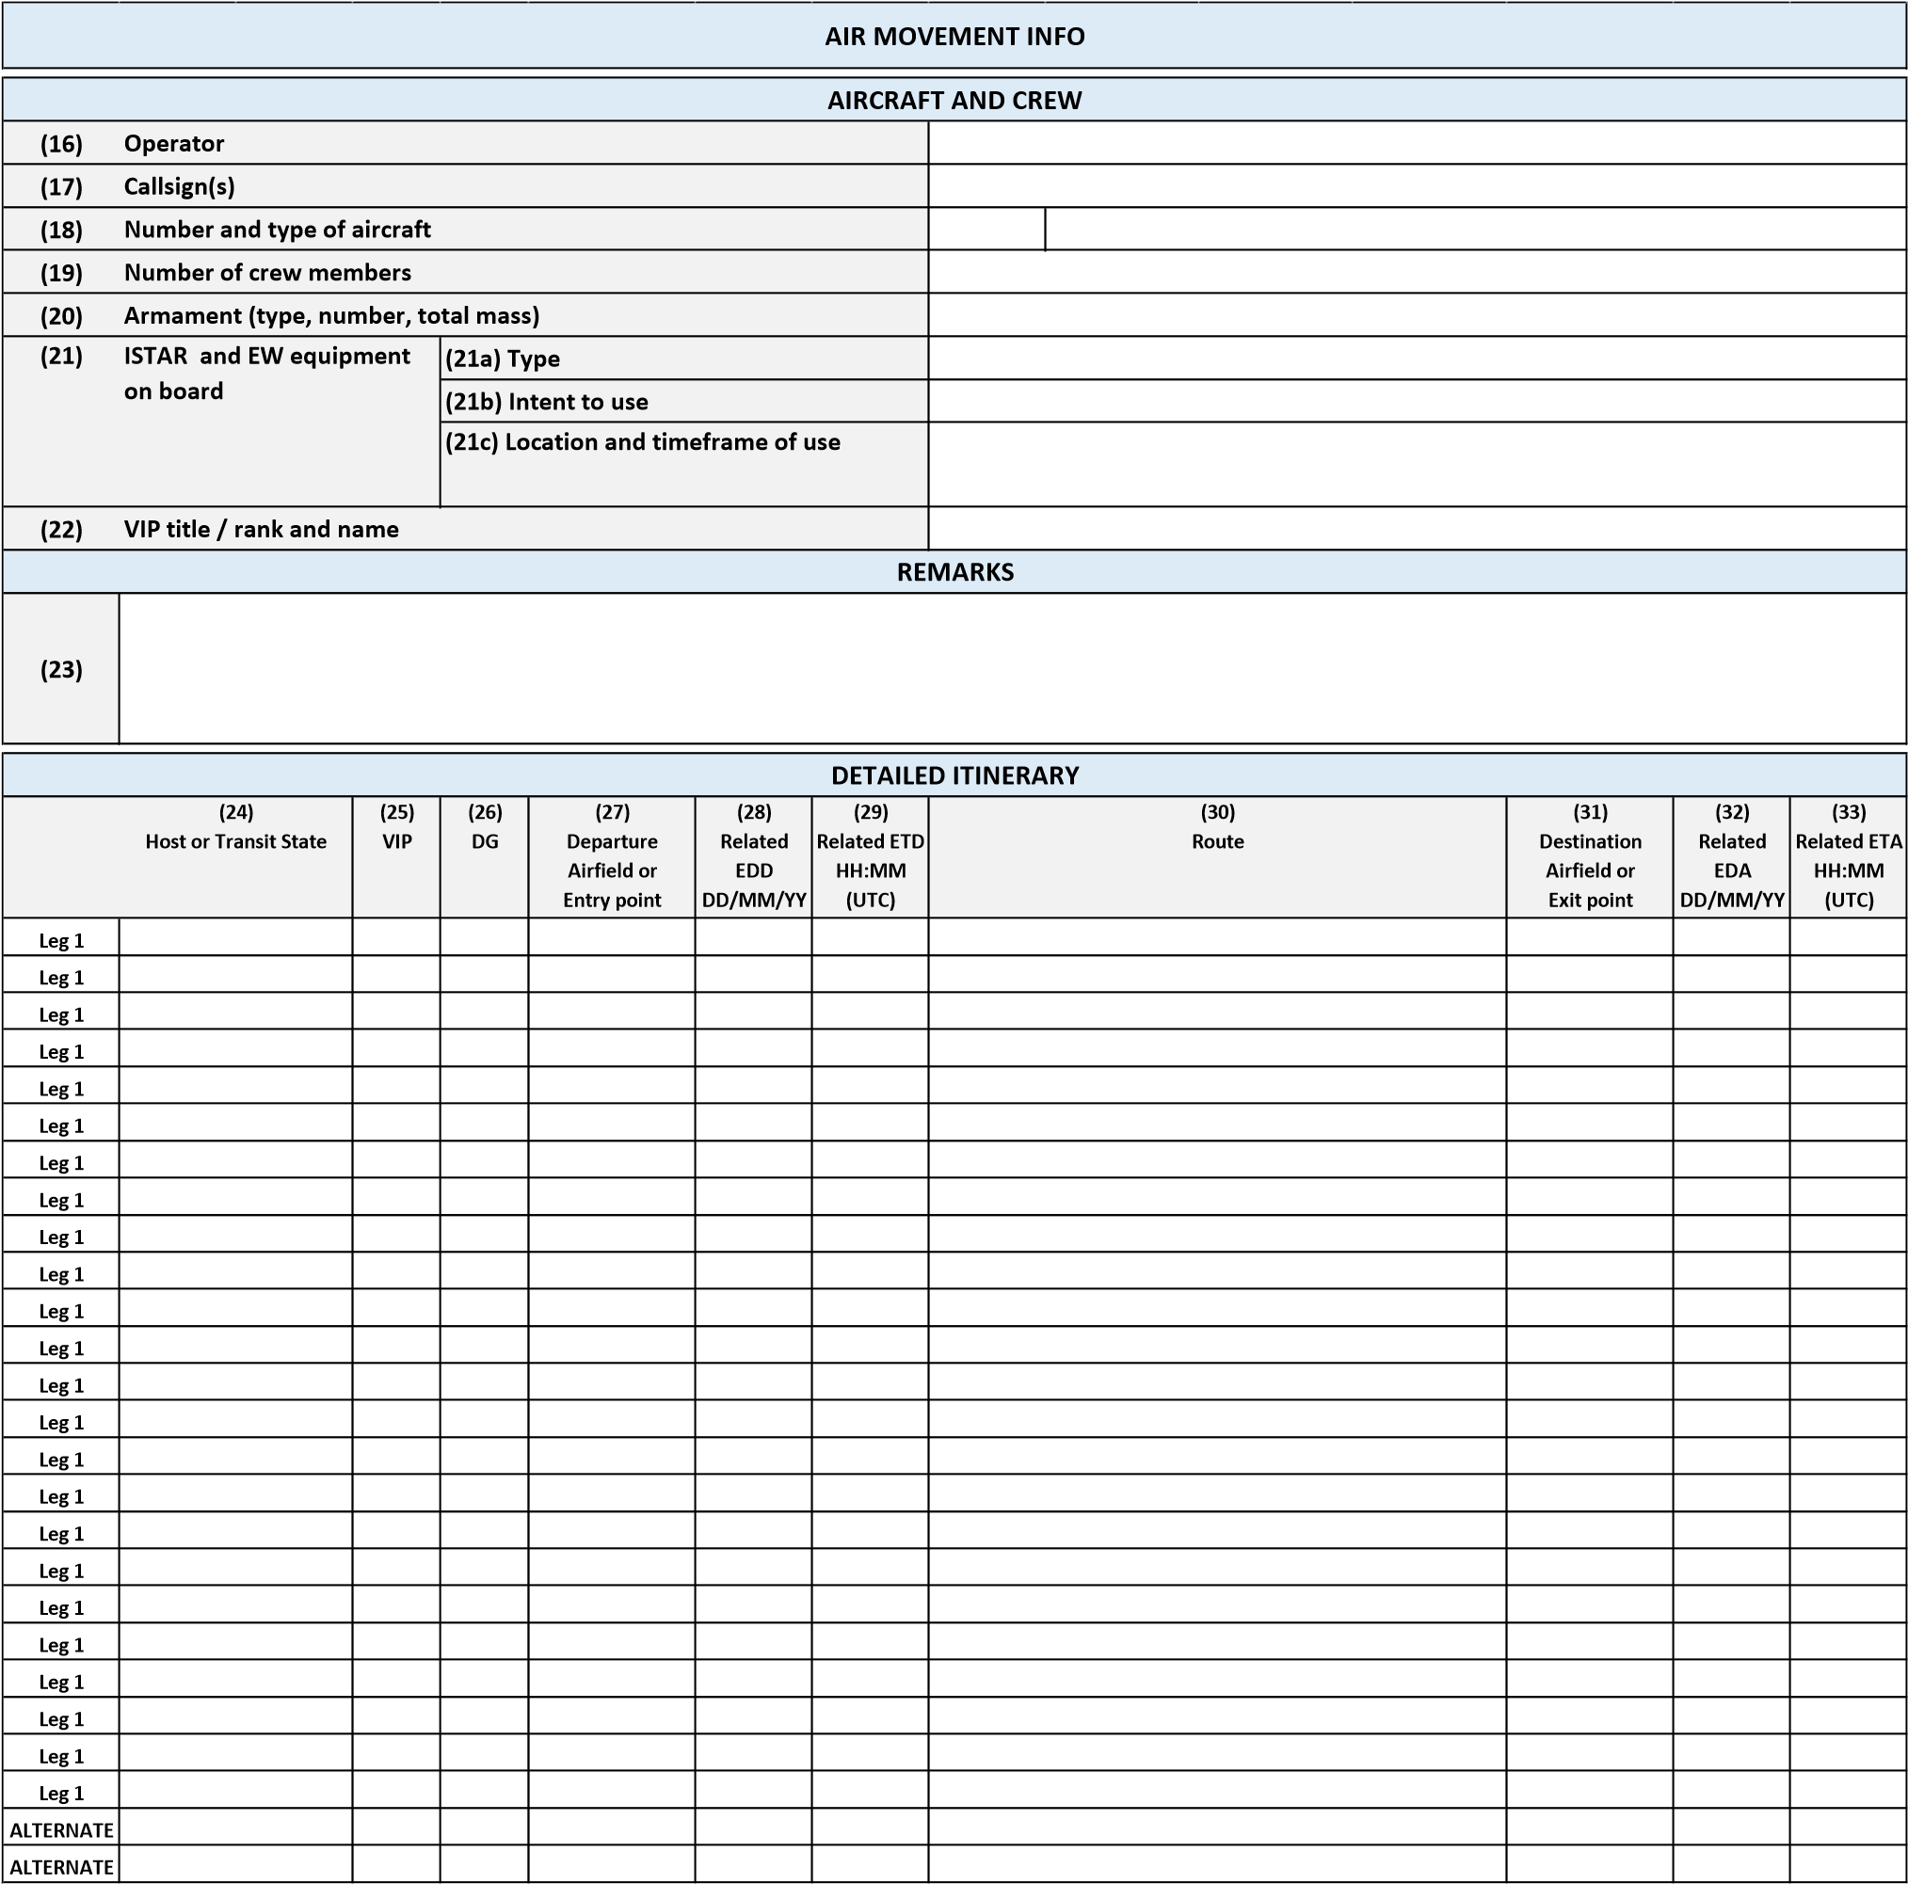
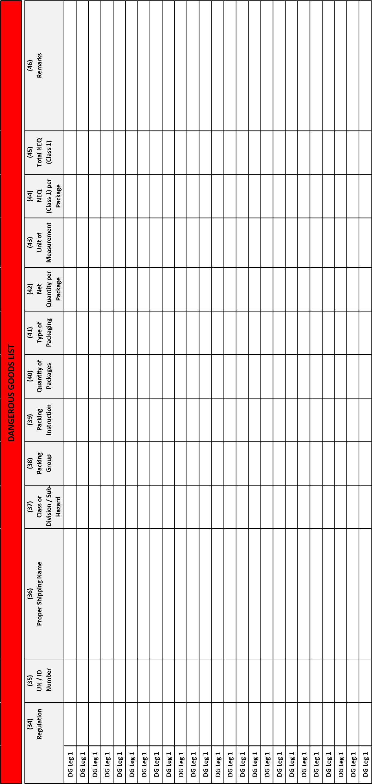

TEMPLATE GUIDE
General instruction
* | This form has to be filled in English and in capital letters.
** | All times must be in UTC.
Guide for each item to be inserted
Movement Request
(1) | Movement Identification Number: This is a placeholder field. Currently, the Movement Idebtification Number is not used for air-movements. Once it applies in the future, the following definition shall apply for this field: Movement Identification Number, created by requester. One Movement Identification Number refers to a single movement. For change of request or notification enter the number you want to change.
(2) | Ad Hoc Request DCN: Diplomatic Clearance Number (DCN) for Ad Hoc Request, created by requester. One DCN refers to a single document and is thus unique to the movement. The Ad Hoc DCN is considered a proposal until the request is approved by the receiving state.
(3) | Submitted to Host or Transit State: State to which this form is submitted.
(4) | R: Insert a ‘X’ if a Ad Hoc request is made to the state specified in column (3).
(5) | N: Insert a ‘X’ if a notification for Annual Permission is made to the state specified in column (3).
(6) | C: Insert a ‘X’ if a change is made concerning the movement data to the state specified in column (3). All changed fields must be listed in the remarks (12) field. Keep the original 'X' in column 4 or 5 as well to indicate whether the change is a change notification or a change request.
(7) | Existing Permission Number: Insert the existing annual DCN in case of an initial notification or a change notification or any other permission number stemming from a bi-/multilateral agreement other than the CBMP Air TA. Insert existing (i.e. previously issued) Ad Hoc DCN for a change request to a previous request.
(8) | Sending State: State requesting or notifying the issues towards the states mentioned in column (3).
(9) | Purpose of Movement: Indicate the purpose of the movement, also the type of cooperate and/or framework if possible.
(10) | Number of Personnel on Board: Estimated total number of personnel on board, incl. crew.
(11) | Sending state contact information: Indicate the name, e-mail address and telephone number of the POC to be contacted for questions related to the request/notification/change.
(12) | Remarks: Additional information related to the request/notification/change. For changes, enter the number or name of the changed fields.
(13) | Approval status / Validity period: Indicate the Ad Hoc Request approval status and validity period of the clearance.
(14) | Host or Transit State contact information: Indicate the name, e-mail address, telephone and mobile phone number of the POC of the receiving (host or transit) state.
(15) | Remarks: Additional information related to the provided clearance.
Air Movement Info
(16) | Operator: Organisation that is operating the aircraft.
(17) | Callsign(s): List all callsigns applicable to this movement. In case the callsign(s) cannot be determined at the time of the request/notification, indicate in  (23) when such information will be provided in advance of the movement. It is typically not sufficient to provide the callsign(s) just in the Air Traffic Control flightplan. The callsign(s) must be provided also through this form to the respective host/transit state contact, unless this requirement is explicitly waived by the host/transit state.
(18) | Number and type of aircraft: Enter appropriate ICAO designator (i.e. C130, F16, etc.). If no designator assigned (or for formation flights comprising more than one type aircraft), indicate ‘ZZZZ’ and specify aircraft type(s) in remarks (23).
(19) | Number of crew members: Insert the total number of crew members.
(20) | Armament (type, number): Indicate whether the aircraft will carry any type of armament. If YES, specify the type and number. Use remarks (23) if needed.
(21) | ISTAR and EW equipment on board: If the aircraft will be equipped with ISTAR and/or EW equipment, specify the type (21a), intention of usage (21b), location and timeframe of use (21c) and additional details in the remarks (23), if needed.
(21a) | Type: Specify type ISTAR / EW equipment installed on aircraft.
(21b) | Intention to use: Yes or no. If partial use is foreseen, specify the details.
(21c) | Location and timeframe of use: Specify geographical location (e.g. training area designator) and timeframe during which equipment will be used. Use remarks (23) if needed.
(22) | VIP title / rank and name: Indicate the title / rank and name of any VIP on board.
(23) | Remarks: Additional information related to the flight details.
(24) | Host or Transit State: State to be overflown.
(25) | VIP: Insert a ‘X’ if there is a VIP on board during this leg.
(26) | DG: Insert a ‘X’ if the flight is carrying dangerous goods (DG) during this leg. In this case, specify DG data in 3_DG_List.
(27) | Departure Airfield or Entry point: Indicate the entry point or the origin airfield ICAO code.
(28) | Related EDD: Indicate the related (27) estimated date of departure DD/MM/YY.
(29) | Related ETD: Indicate the related (27) estimated time of departure HH:MM (UTC).
(30) | Route: Indicate which route will be flown. Alternate routes must be clearly identified by ‘ALTERNATE ROUTE’.
(31) | Destination Airfield or Exit point: Indicate the exit point or the destination airfield ICAO code.
(32) | Related EDA: Indicate the related (31) estimated date of arrival DD/MM/YY.
(33) | Related ETA: Indicate the related (31) estimated time of arrival HH:MM (UTC).
DG List
(34) | Regulation: Select the regulation to be applied (ICAO-T.I., IATA-DGR, AMovP-6, None). Select "None" for a transport that deviates from the selectable DGregulations for any reason and therefore requires an ad-hoc request. Check proper selection of (4) in 1_Movement_Request.
(35) | UN / ID Number: Indicate the UN / ID number (e. g. 0012).
(36) | Proper Shipping Name: Indicate the proper shipping name. Generic or n.o.s.-proper shipping names regularely have to be supplemented by the technical name or chemical group name [e. g. UN 1078, Refrigerant gas, n.o.s. (Tetrafluoromethane)].
(37) | Class or Division / Sub-Hazard: Indicate the hazard class / division / sub-hazard as well as the combatibility group for class 1 items.
(38) | Packing Group: Indicate the packing group, if applicable. If not applicable, indicate "n/a" or leave the cell blank.
(39) | Packing Instruction (PI): Indicate the applicable PI according to the selected regulation (34).
(40) | Quantity of Packages: Indicate the number of packages for which identical data, as specified in this line, apply.
(41) | Type of Packaging: Indicate the type of packaging which is used (e. g. fibreboard box), or insert the packaging code (e. g. "4G") as specified in the applicable PI of the selected regulation.
(42) | Net Quantity per Package: Indicate the net quantity of one package. The Net Qty is either the weight or volume of the DG contained in a package excluding the weight or volume of any packaging material or the weight of an unpackaged article of DG (e. g. UN 3166). For class 1 items it is the weight of the article itself. Example: A wooden box with 100 grenades (each with a pure weight of 0,5 kg) has a Net Qty of 50 kg. The Net Qty per package is one of the decisive factors for determining the compliance / non-compliance with relevant DG-regulations. Whenever the applied regulations require the indication of the gross weight add a letter "G" to the specification.
(43) | Unit of Measurement: Indicate the applicable unit of measurement (e. g. kg, L) in relation to (42) and, if applicable (44).
(44) | NEQ (Class 1) per Package: Indicate the net explosive quantity (NEQ), also called net explosive mass (NEM) or net explosive weight (NEW) or net explosive content (NEC) per package. This is the total mass of the explosive substances, without the packagings, casings, etc. Example: A wooden box with 100 grenades (each with a pure weight of 0,5 kg and a net explosive weight of 0,06 kg has a NEQ per package of 6 kg). The amount of NEQ/NEM/NEC/NEM per package can never exceed the amount of the Net Qty per package.
(45) | Total NEQ (Class 1): Indicate the NEQ (NEW, NEM, NEC) in total for each line. Multiply the number of packages (40) and the NEQ / package (44).
(46) | Remarks: Indicate any remarks [e. g. to highlight amended data in relation of a change request/notification in connection with (6) / (12)].

ANNEX B DECLARATION OF INTENT

The Republic/Kingdom/Government/Ministry/Minister of ….................. represented by ...................................………………………………………..

DECLARING that it wishes to participate in the:
TECHNICAL ARRANGEMENT (TA) Nº A.PRG.CAP672.A
On Cross Border Movement Permission Procedures for Air Movement in Europe (AIR TA);
Acknowledging that the terms in this declaration have the same meaning as in the afore-mentioned Technical Arrangement;
ACCEPTS to:
- participate in the AIR TA as per Chapter V, Section 5 of this TA;
- contribute to the AIR TA and to adhere to all TA provisions including its Annexes and related approved documents in the versions valid at the time;
- mandate the EDA to update the list on the front page of this TA and integrate the signatures at the end of the AIR TA accordingly.

For the Republic/Kingdom/Government/Ministry/Minister of ....…................................…………….
………………………………………………………………….
Date: ...............................

SIGNATURES

The Minister of Defence of the Kingdom of Belgium

Signature

Place
Date

The Ministry of Defence of the Republic of Bulgaria,

Signature

Place
Date

For the Ministry of Defence of the Republic of Croatia,

Signature

Place
Date

The Ministry of Defence of the Republic of Cyprus,

Signature

Place
Date

The Ministry of Defence of the Czech Republic,

Signature

Place
Date

The Ministry of Defence of the Republic of Estonia,

Signature

Place
Date

For the Ministry of Defence of the Republic of Finland,

Signature

Place
Date

The Minister for the Armed Forces of the French Republic,

Signature

Place
Date

The Federal Ministry of Defence of the Federal Republic of Germany,

Signature

Place
Date

The Ministry of National Defence of the Hellenic Republic,

Signature

Place
Date

The Ministry of Defence of the Italian Republic,

Signature

Place
Date

The Ministry of Defence of the Republic of Latvia,

Signature

Place
Date

The Ministry of National Defence of the Republic of Lithuania,

Signature

Place
Date

The Minister of Defence of the Grand Duchy of Luxembourg,

Signature

Place
Date

The Minister of Defence of the Kingdom of the Netherlands,

Signature

Place
Date

The Ministry of Defence of the Kingdom of Norway,

Signature

Place
Date

The Minister of National Defence of the Republic of Poland,

Signature

Place
Date

The Ministry of National Defence of the Portuguese Republic,

Signature

Place
Date

The Ministry of National Defence of Romania,

Signature

Place
Date

The Ministry of Defence of the Slovak Republic,

Signature

Place
Date

The Ministry of Defence of the Republic of Slovenia,

Signature

Place
Date

The Ministry of Defence of the Kingdom of Spain,

Signature

Place
Date

The Government of the Kingdom of Sweden

Signature

Place
Date

The European Defence Agency

Signature

Place
Date

According to the OJ C321(31/12/2003). The reference should now read Article 42 (1) and 43 (1) TEU (ex-Art. 17).

